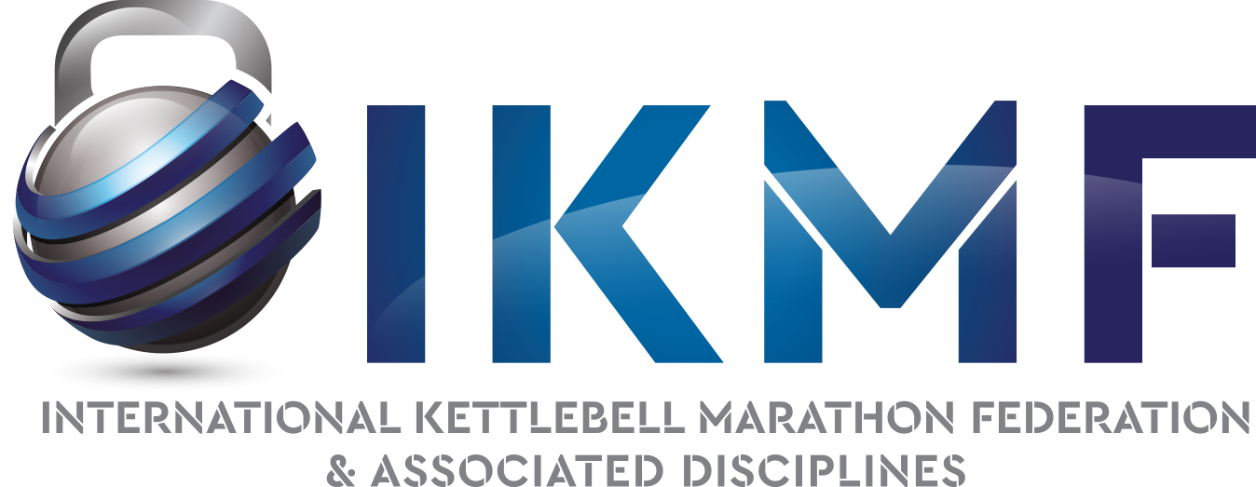

ENGAGEMENT OF IKMF COUNTRY REPRESENTATIVES

You have chosen to become an IKMF National Representative in your country and we appreciate it.
We are aware that this is voluntary work but, as in every organization, we must put “rules” in place.

IKMF Commitment
1. The IKMF undertakes to appoint you as the sole national representative of the IKMF and you will be the sole contact for us.
2. The IKMF undertakes to recognize only one captain of your national team.
3. IKMF gives you the right to vote for all IKMF decisions
4. The IKMF can offer to organize a continental or world championship. Under employment contract.
5. IKMF authorizes you to use its logos.

Your engagement
1. You must promote the IKMF in your country without bias or discrimination against athletes from your country, as well as on social media.
2. You must respect the rules of IKMF competitions (all: marathon, pentathlon IKMF games and extreme marathon)
3. You must organize one national competition per year in your country
4. You need to create a team in your country
5. You are required to use the IKMF Logos during National, Continental and world competitions
6. You must donate 30% of registrations to IKMF, for the continental and world championships.

Forbidden:
IKMF is a non-profit organization; you cannot do business (internship, t-shirts, clothing, without the authorization of the IKMF president) with the IKMF logos. The use of these logos for commercial purposes belongs by right to its designer: Stéphane Dauvergne, IKMF president.
Allowed:
You can use these logos for commercial purposes only during the official IKMF continental and world championships to create souvenirs of the competition (t-shirts, mugs, calendars, etc.)

Any transgression during this commitment may result in sanctions, up to and including the loss of your IKMF statue.
IKMF is free to change its country representative if it considers that the latter is not doing its representative job correctly.

Sincerely,

Name of country representative: Dauvergne Stephane IKMF President
Signature Signature

